**­­Schedules:**

Schedules are avoided by most students as they appear restrictive and limiting whereas students generally wish to use their time with more freedom. This however proves to be a counterproductive approach to thinking. In truth, schedules add more freedom to students lives as they allow a person’s time to be used more efficiently. Instead of time being spent in idle procrastination, making and abiding by a schedule allows people to spend time achieving the goals they set.

Reasons people don’t use schedules:

1. It takes upfront effort and planning
2. (Jordan Peterson)Easier to ignore failures if boundaries have not been set (Wilful blindness)
3. Learned helplessness. Phycology derivatives and theory of depression. Learned helplessness is when we learn to believe we are helpless. We assign our identity to failures, simply telling ourselves ‘I’m just not the kind of person that can do well at this’. Fix by telling yourself that a failure isn’t who you are, if you fail then you did something wrong and need to now change things and try again.

How to stick to schedule:

1. Removing from yourself the idea that you are a failure
2. Be cognizant of how you use your time. Understand what your spending your time on.
3. Choose a calendar of choice and use it to plan all things – educational and leisure.

Traps: not allocating buffer time like transportation, preparation etc.

Don’t be too ambitious with how much work you need to do.

Review and adjust your schedule as you go. Review your schedule

**Study more effectively:**

Active vs passive learning:

Passive is easier, less effort, more comfortable

Active learning is more challenging, less comfortable but much more effective.

1. Identify what information is important
2. Organise information in a method that you understand. Charts or posters or cards etc.
3. Memorize: memorise actively.
4. Apply the information in practice questions.

Studying environment is important, what’s important for you mate? Wake up same time, study in same spaces and such to form habits and fight procrastination. Writing is better than typing your notes. Writing helps with recall due to motor coordination between eye and hands.

Don’t bother watching lectures again, that is passive learning and It doesn’t help at all. Reviewing written or digital notes is a waste of time. Better way is to rewrite and rephrase your notes by condensing what you’ve already done and rewriting notes to be shorter but convey the same amount of information.

Spaced repetition. Repeating helps learning, and to memorise you have to repeat after given intervals like described below.

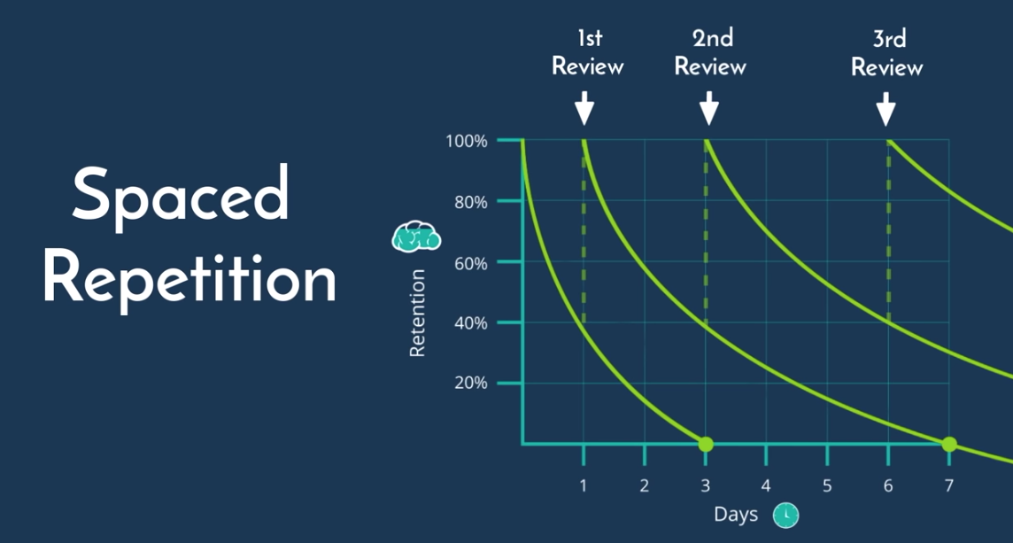

Recall better than recognition with revising. Forces you to extract information instead of just recognizing it.

Richard Feynman made a Feynman technique.

Write the concept name on the top.

Beneath it, explain this concept to a friend who has no idea what you’re on about. You’ll come across things you can’t properly simplify.

Look up areas you’re having trouble explaining simply.

Identify complex areas and simplify them further. Use analogies or whatever if it helps.

How would you explain this to a child.

Use it for complicated things and complicated concepts. Not for memorization. For that there’s other things mentioned.

Pomodoro technique

History: invented in 1990’s. by Francesco Cirillo

Used to improve productivity

Break up any task or series of tasks into short timed intervals called Pomodoro’s

Pomodoro’s are separated by short breaks (as brains have limited attention spans

1. Choose a task or series of tasks to be completed.
2. Set timer to 25minutes – don’t constantly check timer
3. When timer goes off, take 5 minute break…make sure to get up during this time.
4. After 4 cycles of Pomodoro take a 20mins break
5. Limit any distractions during work sessions
6. Modify work and break time intervals as preferred

Maintain momentum. Sleep and wake at a given time. Audio books are a good way to make otherwise useless time useful. Fill in brief moments of time with short bursts of studying.

Anki

-there should be deck system (so you can have 1 deck per exam)

-basic card: flash card with a front and back: opening card shows front and clicking shows back: so front can ask question, and back can have answer. Active learning technique

Close deletions card type: fill in the blank type cards, copy and paste text with blank parts that chow up when you click/

Ability to insert images where relevant helps with recall

Don’t watch lectures again pointlessly

Summarise what shit in your own words

Don’t review notes blindly. Reading. Summarise the information. Condense the notes you got. Make it easier to revise.

Spaced repetition: keep repeating content, with space between repetitions depending on when you’re about to forget. 0,1,3,6,11…

Make sure you’re well rested before an examination.

Self-discipline:

Self-discipline allows us to live our lives in the way we actually want to.

Brain is like a muscle with a limited amount of discipline. Studies about brain discipline muscle. We don’t have infinite reserves of willpower, we have what we have, we just got to divide it properly see?. 3 wimple steps to develop self-discipline : start small, break up large goals into small tasks so doing that stuff is not that discipline intensive. Practice daily. Ramp up, as your small tasks increase in momentum, do for the big goals.

Incentivise yourself with rewards for doing the right thing. improve. Slowly, in steps. Improve. Focus on developing skills. Mastery of skills.

How to improve productivity and efficiency

Since time is limited, maximise it. Trying to relax and work at the same time is bad.

A common mistake is wasting time to save a few bucks. Determine what your time is worth.

Parkinson’s law: allows you to do more work in less time, helps efficiency.

Have tasks you can perform anywhere. Use anki flash cards to revise when in a queue or something.

Optimise your breaks and switch your tasks to maintain focus.

Doing the things you have to do every day anyway to take a mental break. Switch task to something else to change your mind getting distracted due to boredom.

Study effectively:

Study hacks